**Course Number: AIT 524**

**Shane Armstrong**

**Week 12 Homework Assignment 11 Subqueries**

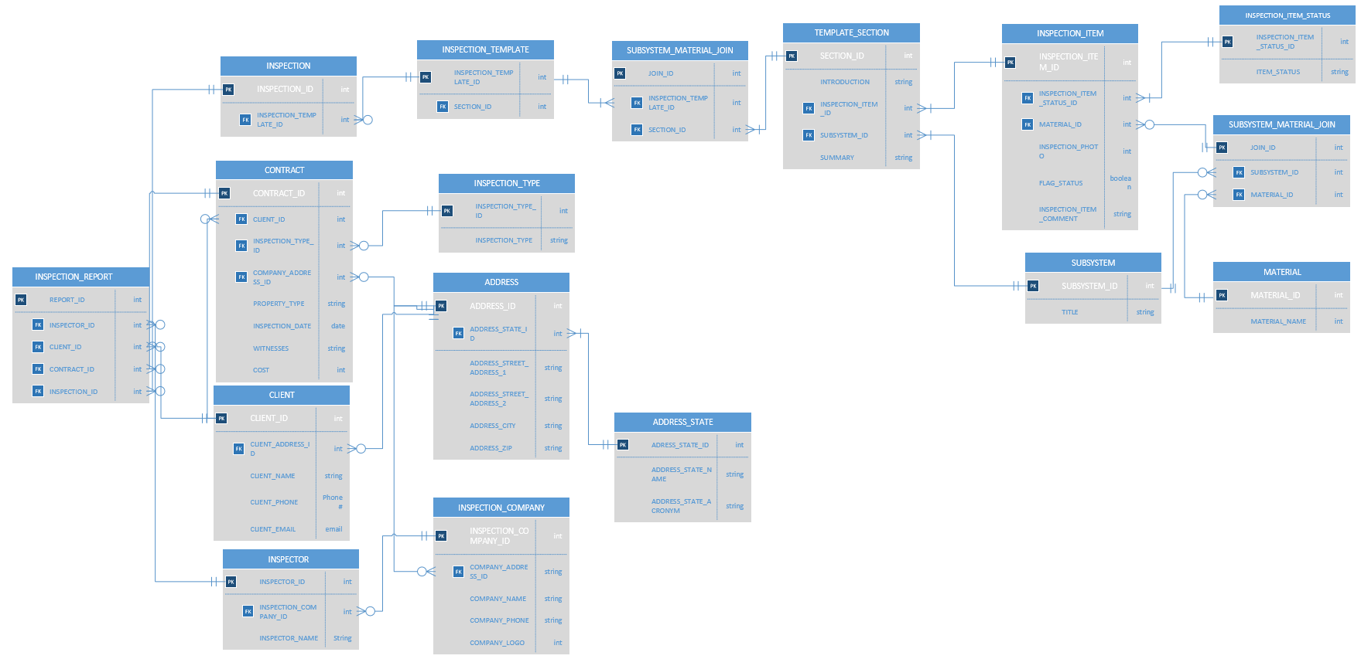

Write four SQL queries to join two or more tables where each query contains multiple combined single-row functions. Explain what each query is intended to do.

1. Query the first half of clients that recieved inspections

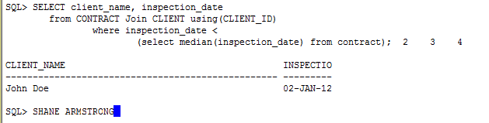

1. Query the clients that have costs greater than or equal to the the averge cost of their property type

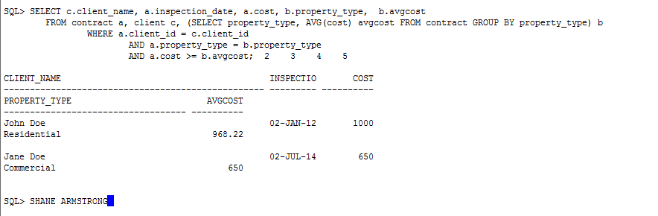

1. Query of the clients and their property types of contracts that had greater contract prices than the average contract price

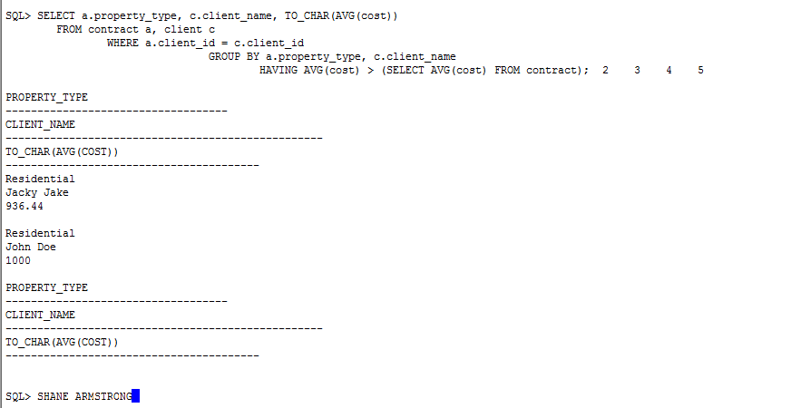

1. Query of the clients and their state whose contracts were more expensive than the most expensive state average cost

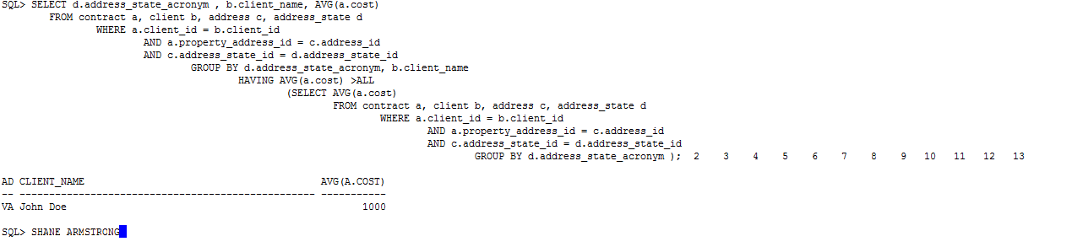

1. Query of the clients, their contract cost, and the average contract cost

